**Net Biodiversity Effect on Stability and Functioning**

Fig.1: Relationship between NBE on Functioning (Func) and NBE on Stability. Each dot represents one replicate/combination (N=189).

Fig.2: Relationship between NBE on Functioning (Func) and NBE on Stability. Each dot represents one replicate/combination (N=189). The color represents temperature treatments.

Fig. 3: Temporal stability, calculated as the coefficient of variation, over the species richness gradient. Each dot represents one replicate/ combination. Colors indicate different temperature treatments.

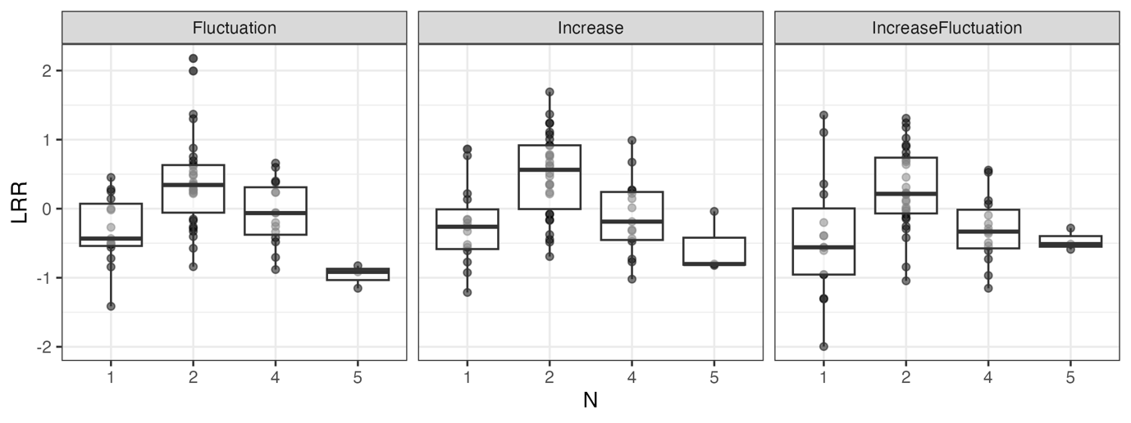

Fig. 3: Resistance, calculated as the log response ratio at day 6, over the species richness gradient. Each dot represents one replicate/ combination.